How to Submit a Records Request | 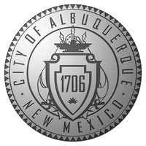
  - MAKING A REQUEST

Instructions
- Go to abqrecords.cabq.gov to start your public records request.
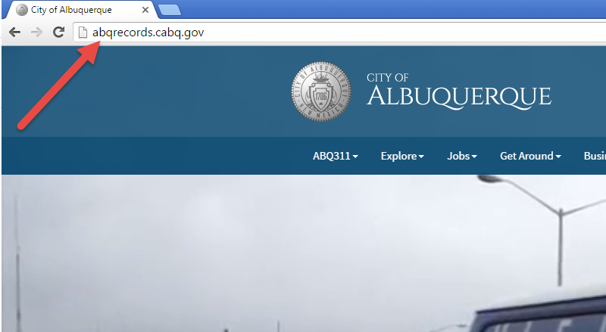

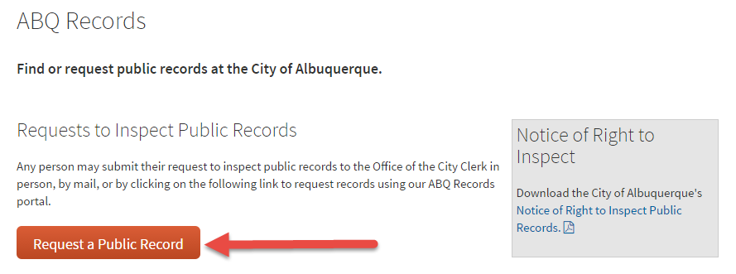
- Click on “Request a Public Record”
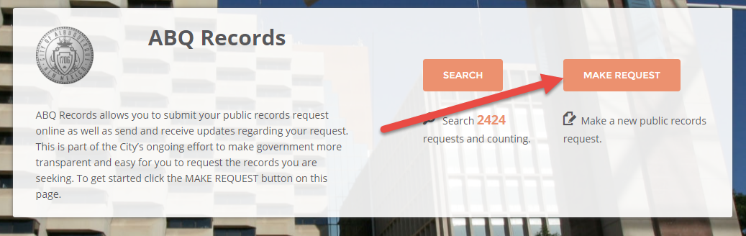
- From the home page, click on “MAKE REQUEST”:

- Enter the description of your request in the description box. NOTE: Click in the box or press the tab button once your description is complete.
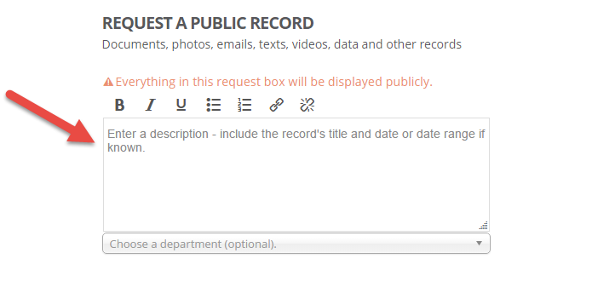

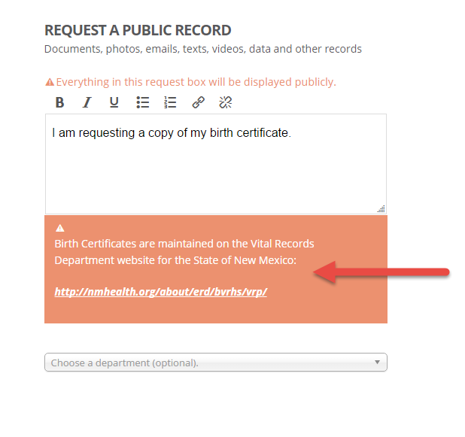
- Look out for a “Smart Alert” that might immediately direct you to the records you are seeking right away, or refer you to the agency that maintains the information you are looking for

- Choose the department you want to request the records from. NOTE: If you do not know the department that maintains the records, you may leave it blank.
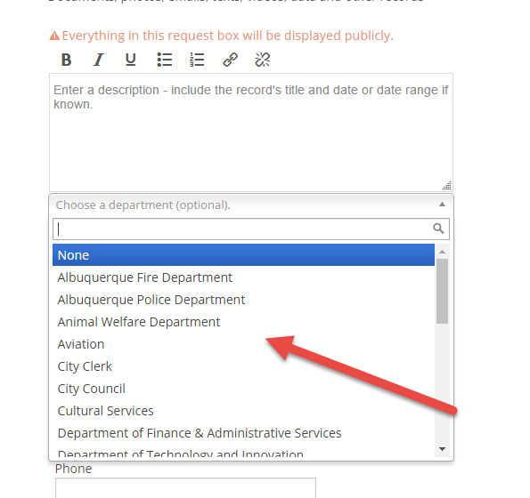

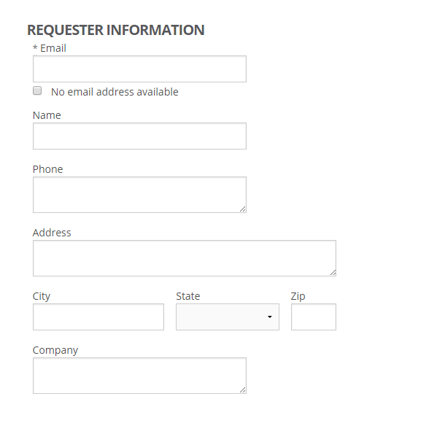
- If there is not a Smart Alert, continue to enter your information (name, phone number, and address are required to make a public records request as mandated by the State of New Mexico’s IPRA Guidelines):

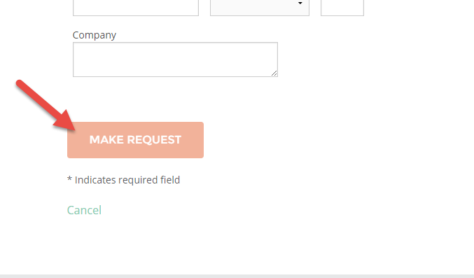
- Click “MAKE REQUEST” button on the bottom of the page to submit your request:

- You will see a message indicating your request has been submitted successfully to the email address provided:
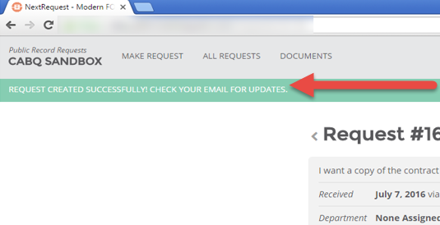

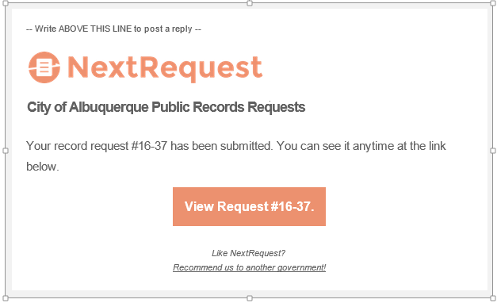
- You will also receive an email indicating your request has been submitted with the request ID:

